# TITLE:

# Contributions of human activities to suspended sediment yield during storm events from a steep, small, tropical watershed

## ABSTRACT

Abstract text goes here....

## Introduction

Introduction text goes here....

Anthropogenic watershed disturbance by industry, agriculture, deforestation, roads, and urbanization alters the timing, composition, and mass of sediment loads to coral reefs, causing enhanced sediment stress on corals near the outlets of impacted watersheds (Syvitski et al., 2005; West and van Woesik, 2001). Anthropogenic sediment disturbance may be exacerbated on volcanic, tropical islands characterized by high rainfall, extreme weather events, steep slopes, erodible soils, and naturally dense vegetation, where land clearing alters the fraction of exposed soil much more than in regions with sparse vegetation. On Molokai, Stock et al. (2010) found that less than 5% of the land produces most of the sediment, and of that 5%, only 1% produces ~50% of the sediment, concluding that management should focus on identifying, quantifying, and mediating erosion hotspots (Risk, 2014). However, knowledge of fluvial suspended sediment yield (SSY) on most Pacific volcanic islands remains limited due to the challenges of in situ monitoring, and existing sediment yield models are not well-calibrated to the climatic, topographic, and geologic conditions found on steep, tropical islands (Calhoun and Fletcher, 1999). Developing models that predict SSY from small, mountainous catchments is a significant contribution for local coral conservation, and can also further improve models applied at the regional scale (Duvert et al., 2012).

Traditional approaches to quantifying human impact on sediment yield, including comparison of total annual yields (Fahey et al., 2003) and sediment rating curves (Asselman, 2000; Walling, 1977), are complicated by interannual variability and hysteresis in the discharge-concentration relationship. As an alternative, recent studies (Basher et al., 2011; Duvert et al., 2012) have compared SSY generated by storm events of the same magnitude to detect human impacts and develop empirical models. SSY generated by individual storm events (SSYEV) may correlate with various precipitation and discharge variables (“storm metrics”), including total precipitation, the Erosivity Index, total discharge, or maximum event discharge (Qmax), but the best correlation has consistently been found with Qmax. Qmax integrates the whole hydrological response of a watershed, making it a good predictor variable of SSYEV in diverse environments (Duvert et al., 2012; Rankl, 2004). High correlation between SSYEV and Qmax has been found in semi-arid, temperate, and sub-humid watersheds in Wyoming (Rankl, 2004), Mexico, Italy, France (Duvert et al., 2012), and New Zealand (Basher et al., 2011; Hicks, 1990), but this approach has not been attempted for steep, tropical watersheds on volcanic islands.

The anthropogenic impact on SSY may vary by storm magnitude, as documented in Mediterranean climates (White and Greer, 2006) and in Pacific Northwest forests (Lewis et al., 2001). As storm magnitude increases, water yield and/or SSY from natural areas may increase relative to human-disturbed areas, diminishing anthropogenic impact. While large storms account for most SSY in natural conditions, human-disturbed areas may show the most significant disturbance for smaller storms (Lewis et al., 2001). It is hypothesized that the disturbance ratio (DR) is highest for small storms, when background SSY from the undisturbed forest is low and erodible sediment from disturbed surfaces in the lower watershed is the dominant source. For large storms, it is hypothesized mass movements and bank erosion contribute to naturally high SSY from the undisturbed upper watershed, reducing the DR for large events.

This study uses in situ measurements of precipitation, stream discharge, and suspended sediment concentration to quantify sediment yield from key areas of the watershed and develop an empirical model of storm-generated sediment yield to a priority coral reef. The questions addressed include: How has human disturbance increased sediment loading to Faga’alu Bay? How do sediment contributions from human-disturbed areas and undisturbed areas vary with storm size? And Which is the best predictor of storm event suspended sediment yield (SSYEV): total precipitation, Erosivity Index, total discharge, or maximum event discharge?

## Study Area

Study Area text goes here....referring to Figure1



Figure 1. Faga'alu watershed showing upper (undisturbed) and lower (human-disturbed) subwatersheds.

### Climate

### Land Use

Land use text goes here...referring to Table 1

|  |  |  |  |  |  |  |  |  |
| --- | --- | --- | --- | --- | --- | --- | --- | --- |
| Table 1. Land use categories in Fag'alu and Nu'uuli watersheds CITATION | | | | | | | | |
| Subwatershed | Cumulative Area km2 | % | % High Intensity Developed | % Developed Open Space | % Grassland (agriculture) | % Forest | % Scrub/ Shrub | % Bare Land |
| FOREST(UPPER) | 0.9 | 48.2 | 0.0 | 0.0 | 0.1 | 82.4 | 17.1 | 0.4 |
| QUARRY | 1.17 | 63.0 | 0.2 | 0.0 | 0.2 | 84.7 | 13.3 | 1.6 |
| VILLAGE(TOTAL) | 1.78 | 95.5 | 3.2 | 0.9 | 0.2 | 85.7 | 9.0 | 1.1 |
| Fagaalu Stream | 1.86 | 100.0 | 4.6 | 1.1 | 0.2 | 84.5 | 8.6 | 1.0 |

Quarry description text goes here...Picture is of the quarry (Figure 2).



Figure 2. Photos of the open-pit aggregate quarry in Faga'alu in 2012 (Top) and 2014 (Bottom). Photo: Messina

## Methods

Methods text goes here...

## Results

### Field Data Collection

#### Precipitation

Precipitation text goes here...

#### Water Discharge

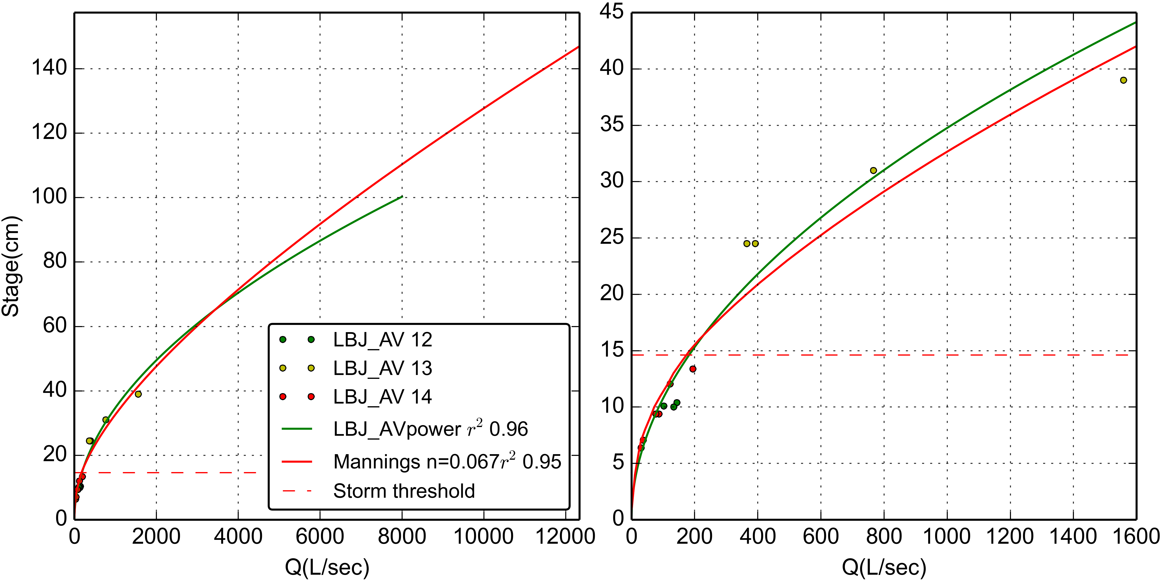

Figure 3. Stage-Discharge relationships for stream gaging site at VILLAGE.

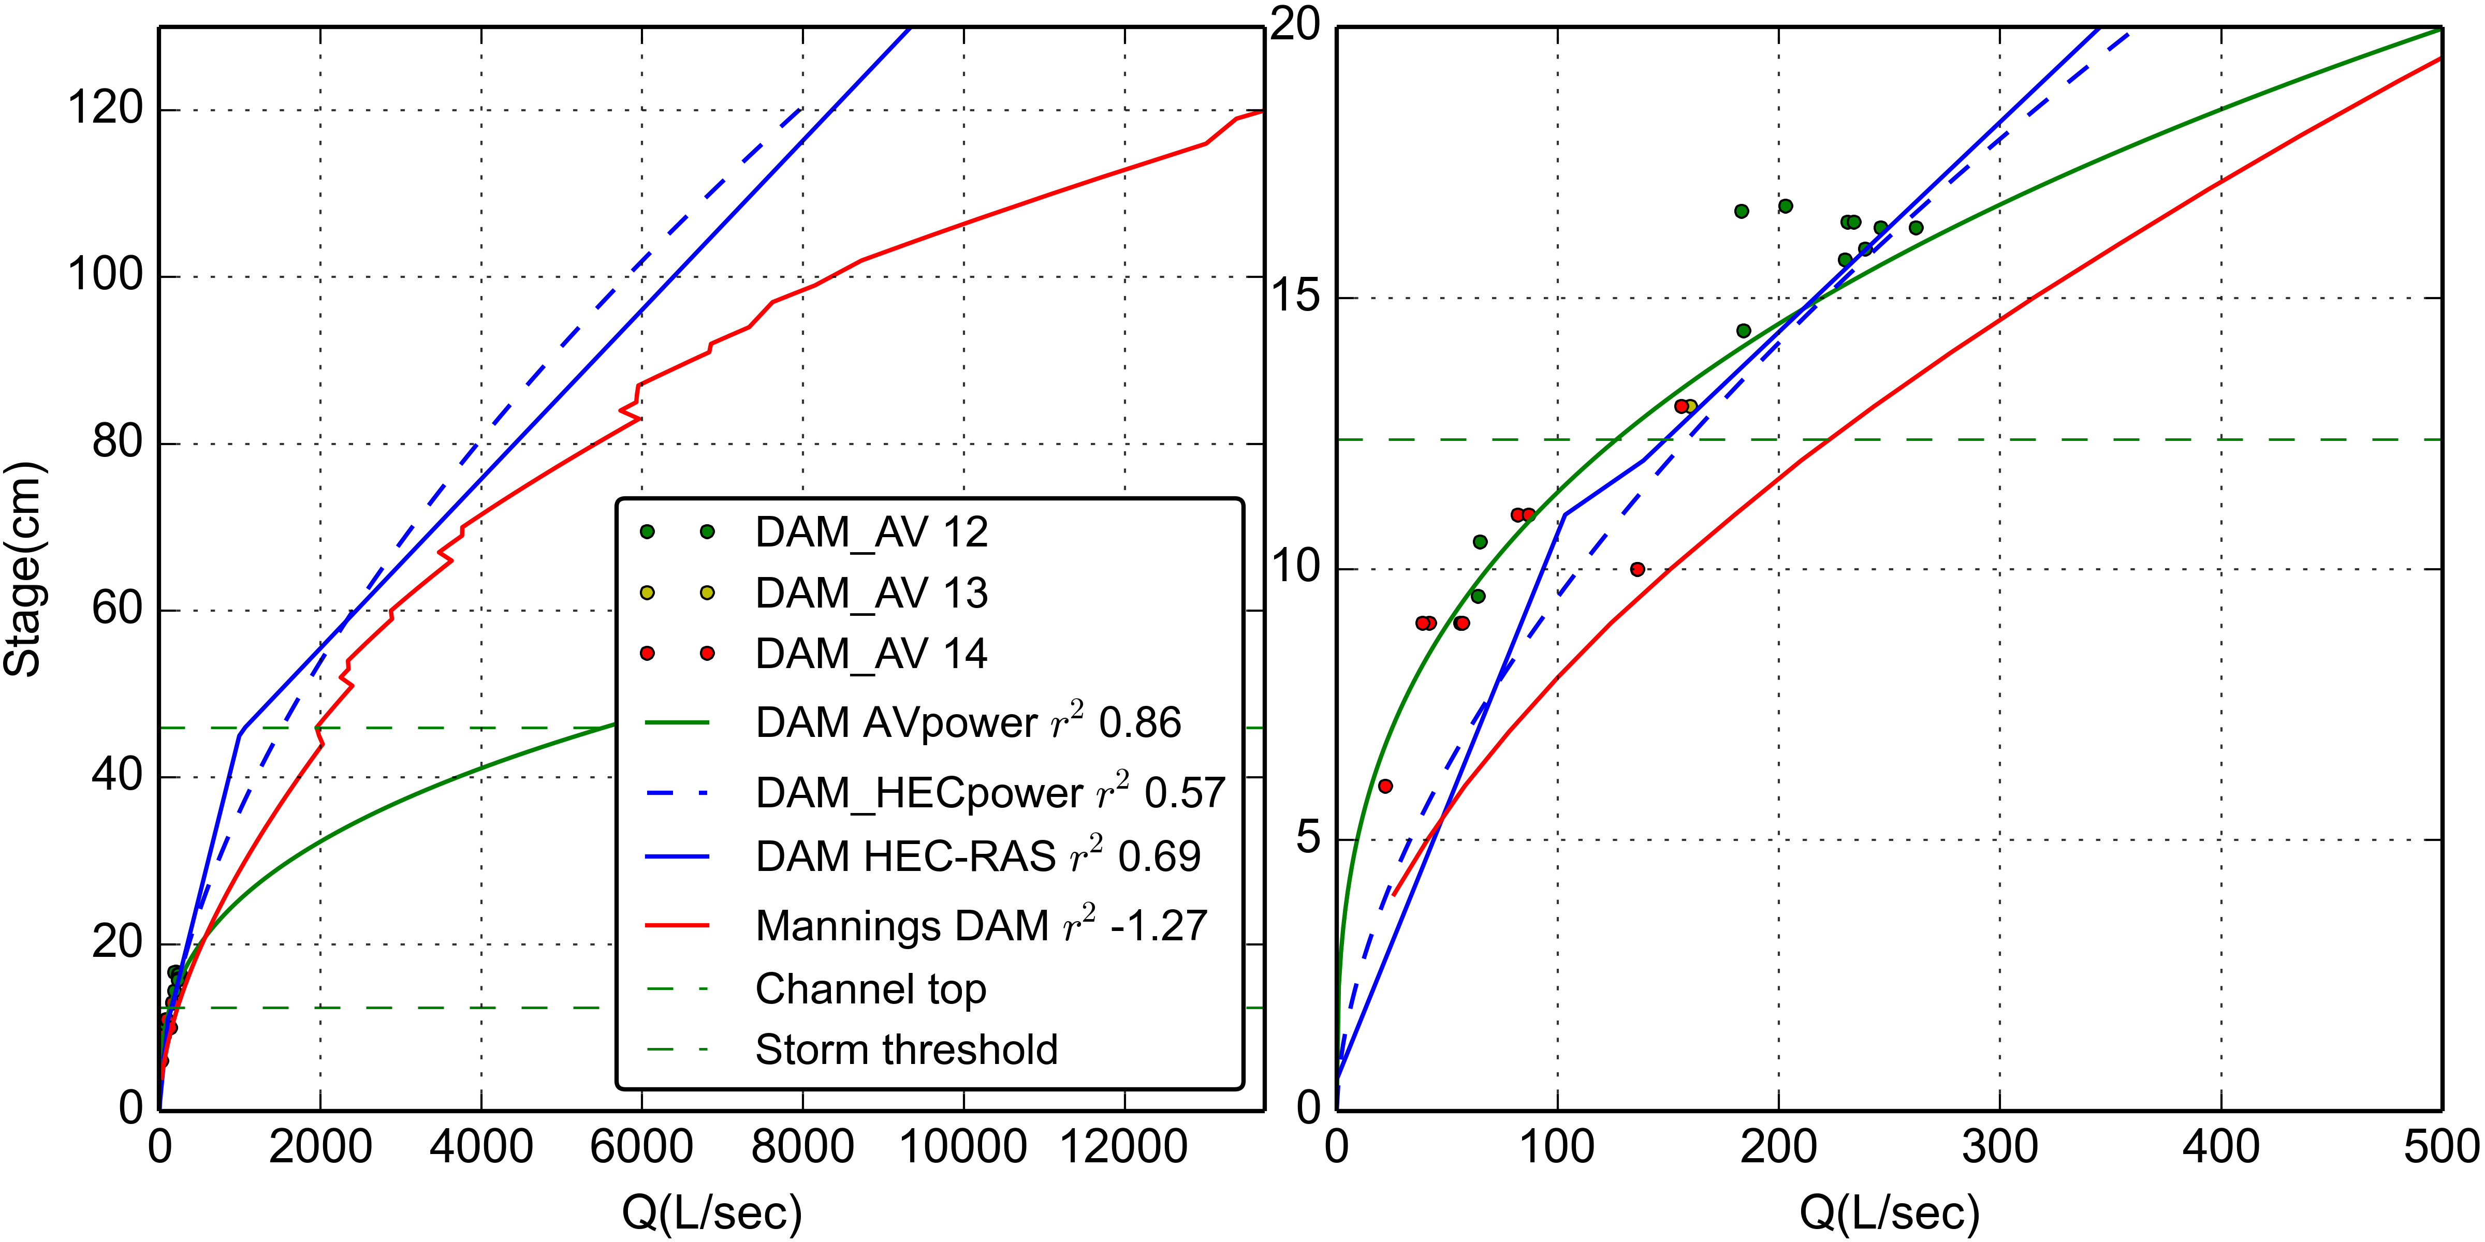

Figure 4. Stage-Discharge relationships for stream gaging site at FOREST.

|  |  |  |  |  |  |  |  |
| --- | --- | --- | --- | --- | --- | --- | --- |
| Table 2. Water discharge from subwatersheds in Faga'alu | | | | | | | |
| Storm Start | Storm# | Precip (mm) | UPPER m3 | LOWER m3 | TOTAL m3 | % Upper | % Lower |
| 2012-01-25 03:45:00 | 1 | 75 | 13593 | 12823 | 26416 | 51 | 48 |
| 2012-02-02 06:00:00 | 2 | 16 | 8275 | 13004 | 21279 | 38 | 61 |
| 2012-02-03 01:15:00 | 3 | 24 | 14230 | 20384 | 34614 | 41 | 58 |
| 2012-02-05 10:00:00 | 4 | 19 | 7983 | 11793 | 19776 | 40 | 59 |
| 2012-02-05 23:00:00 | 5 | 83 | 48857 | 65645 | 114502 | 42 | 57 |
| 2012-02-23 20:45:00 | 6 | 17 | 8089 | 9803 | 17892 | 45 | 54 |
| 2012-03-08 16:30:00 | 7 | 23 | 3550 | 2886 | 6436 | 55 | 44 |
| 2012-03-09 06:00:00 | 8 | 18 | 8871 | 7173 | 16044 | 55 | 44 |
| 2012-03-16 10:00:00 | 9 | 22 | 4251 | 5603 | 9854 | 43 | 56 |
| 2012-03-17 11:45:00 | 10 | 30 | 4540 | 6315 | 10855 | 41 | 58 |
| 2012-03-21 20:15:00 | 11 | 14 | 5837 | 6330 | 12167 | 47 | 52 |
| 2012-03-22 21:45:00 | 12 | 35 | 10408 | 14116 | 24524 | 42 | 57 |
| 2012-03-25 03:30:00 | 13 | 49 | 25402 | 24620 | 50022 | 50 | 49 |
| 2012-05-02 16:15:00 | 14 | 30 | 762 | 2633 | 3395 | 22 | 77 |
| 2012-05-08 04:45:00 | 15 | 25 | 2966 | 3046 | 6012 | 49 | 50 |
| 2012-05-22 18:45:00 | 16 | 33 | 12356 | 10608 | 22964 | 53 | 46 |
| 2012-05-23 07:45:00 | 17 | 88 | 103976 | 18352 | 122328 | 84 | 15 |
| 2012-05-24 20:00:00 | 18 | 34 | 40233 | 18629 | 58862 | 68 | 31 |
| 2012-05-26 01:30:00 | 19 | 40 | 32280 | 21700 | 53980 | 59 | 40 |
| 2012-06-03 10:15:00 | 20 | 19 | 12090 | 7831 | 19921 | 60 | 39 |
| 2012-06-04 00:15:00 | 21 | 49 | 32590 | 11482 | 44072 | 73 | 26 |
| 2012-06-04 14:30:00 | 22 | 52 | 48663 | 39327 | 87990 | 55 | 44 |
| 2012-06-06 21:15:00 | 23 | 12 | 7998 | 5108 | 13106 | 61 | 38 |
| 2012-06-07 07:30:00 | 24 | 10 | 9453 | 6331 | 15784 | 59 | 40 |
| 2012-07-08 02:00:00 | 25 | 33 | 3865 | 3468 | 7333 | 52 | 47 |
| 2012-07-27 02:15:00 | 26 | 28 | 1610 | 2545 | 4155 | 38 | 61 |
| 2012-07-27 20:30:00 | 27 | 2 | 1393 | 1199 | 2592 | 53 | 46 |
| 2012-08-09 03:30:00 | 28 | 36 | 14362 | 6558 | 20920 | 68 | 31 |
| 2013-03-05 18:45:00 | 29 | 33 | 3658 | 12948 | 16606 | 22 | 77 |
| 2013-03-06 09:15:00 | 30 | 21 | 7731 | 20126 | 27857 | 27 | 72 |
| 2013-03-07 14:30:00 | 31 | 34 | 23142 | 59593 | 82735 | 27 | 72 |
| 2013-03-11 02:15:00 | 32 | 43 | 17184 | 35671 | 52855 | 32 | 67 |
| 2013-03-21 13:15:00 | 33 | 15 | 1074 | 2654 | 3728 | 28 | 71 |
| 2013-03-23 11:00:00 | 34 | 1 | 538 | 4238 | 4776 | 11 | 88 |
| 2013-04-16 11:00:00 | 35 | 53 | 9475 | 25404 | 34879 | 27 | 72 |
| 2013-04-17 00:00:00 | 36 | 42 | 15628 | 38117 | 53745 | 29 | 70 |
| 2013-04-20 04:30:00 | 37 | 27 | 3860 | 18755 | 22615 | 17 | 82 |
| 2013-04-23 13:30:00 | 38 | 83 | 59162 | 28128 | 87290 | 67 | 32 |
| 2013-04-30 15:00:00 | 39 | 112 | 79138 | 35622 | 114760 | 68 | 31 |
| 2013-05-11 14:30:00 | 40 | 0 | 956 | 1843 | 2799 | 34 | 65 |
| 2013-06-05 05:45:00 | 41 | 170 | 134031 | 20593 | 154624 | 86 | 13 |
| 2013-06-16 03:15:00 | 42 | 28 | 7521 | 5179 | 12700 | 59 | 40 |
| 2013-07-17 03:30:00 | 43 | 11 | 1332 | 1276 | 2608 | 51 | 48 |
| 2013-07-17 23:00:00 | 44 | 25 | 10739 | 20923 | 31662 | 33 | 66 |
| 2013-07-19 08:45:00 | 45 | 51 | 23090 | 54215 | 77305 | 29 | 70 |
| 2013-08-05 23:45:00 | 46 | 14 | 4925 | 5257 | 10182 | 48 | 51 |
| 2013-08-10 04:30:00 | 47 | 73 | 21904 | 57448 | 79352 | 27 | 72 |
| 2013-08-15 19:00:00 | 48 | 27 | 2719 | 5881 | 8600 | 31 | 68 |
| 2013-08-16 08:00:00 | 49 | 192 | 110918 | 126799 | 237717 | 46 | 53 |
| 2013-08-19 06:45:00 | 50 | 36 | 13121 | 24669 | 37790 | 34 | 65 |
| 2013-09-01 08:30:00 | 51 | 40 | 6499 | 10340 | 16839 | 38 | 61 |
| 2014-02-14 14:45:00 | 52 | 18 | 8187 | 7592 | 15779 | 51 | 48 |
| 2014-02-15 09:00:00 | 53 | 11 | 1521 | 1807 | 3328 | 45 | 54 |
| 2014-02-18 18:15:00 | 54 | 11 | 485 | 1947 | 2432 | 19 | 80 |
| 2014-02-20 11:15:00 | 55 | 29 | 4466 | 16654 | 21120 | 21 | 78 |
| 2014-02-21 11:30:00 | 56 | 51 | 18870 | 38928 | 57798 | 32 | 67 |
| 2014-02-22 07:45:00 | 57 | 0 | 1239 | 1653 | 2892 | 42 | 57 |
| 2014-02-24 05:30:00 | 58 | 20 | 1297 | 1823 | 3120 | 41 | 58 |
| 2014-02-25 21:15:00 | 59 | 60 | 21523 | 50918 | 72441 | 29 | 70 |
| 2014-02-27 02:00:00 | 60 | 35 | 21136 | 25061 | 46197 | 45 | 54 |
| 2014-03-06 19:15:00 | 61 | 43 | 14635 | 20283 | 34918 | 41 | 58 |
| 2014-03-13 12:30:00 | 62 | 14 | 3095 | 4164 | 7259 | 42 | 57 |
| 2014-03-13 16:00:00 | 63 | 20 | 6025 | 7576 | 13601 | 44 | 55 |
| 2014-03-14 00:30:00 | 64 | 16 | 12162 | 17704 | 29866 | 40 | 59 |
| 2014-03-14 18:00:00 | 65 | 11 | 1088 | 2170 | 3258 | 33 | 66 |
| 2014-04-01 08:45:00 | 66 | 32 | 641 | 4594 | 5235 | 12 | 87 |
| 2014-04-06 12:30:00 | 67 | 54 | 15597 | 30876 | 46473 | 33 | 66 |
| 2014-04-08 14:30:00 | 68 | 19 | 2850 | 6041 | 8891 | 32 | 67 |
| 2014-04-09 23:30:00 | 69 | 10 | 2758 | 5448 | 8206 | 33 | 66 |
| 2014-04-11 09:45:00 | 70 | 6 | 998 | 2299 | 3297 | 30 | 69 |
| 2014-04-17 15:00:00 | 71 | 9 | 803 | 1957 | 2760 | 29 | 70 |
| 2014-04-18 18:45:00 | 72 | 17 | 4260 | 9358 | 13618 | 31 | 68 |
| 2014-04-19 06:45:00 | 73 | 36 | 15830 | 47592 | 63422 | 24 | 75 |
| 2014-04-25 15:30:00 | 74 | 20 | 6638 | 11832 | 18470 | 35 | 64 |
| 2014-04-26 11:00:00 | 75 | 0 | 1184 | 1532 | 2716 | 43 | 56 |
| 2014-04-27 11:30:00 | 76 | 23 | 6216 | 15953 | 22169 | 28 | 71 |
| 2014-04-28 09:15:00 | 77 | 16 | 2094 | 6700 | 8794 | 23 | 76 |
| 2014-04-28 21:15:00 | 78 | 41 | 11795 | 43242 | 55037 | 21 | 78 |
| 2014-04-30 11:45:00 | 79 | 34 | 20014 | 41702 | 61716 | 32 | 67 |
| 2014-05-19 13:30:00 | 80 | 25 | 3355 | 6628 | 9983 | 33 | 66 |
| 2014-05-20 01:00:00 | 81 | 13 | 2917 | 6751 | 9668 | 30 | 69 |
| 2014-05-22 13:30:00 | 82 | 62 | 9901 | 35740 | 45641 | 21 | 78 |
| 2014-05-23 08:00:00 | 83 | 4 | 1547 | 5272 | 6819 | 22 | 77 |
| 2014-05-23 23:30:00 | 84 | 4 | 2162 | 6659 | 8821 | 24 | 75 |
| 2014-05-24 09:00:00 | 85 | 2 | 601 | 1962 | 2563 | 23 | 76 |
| 2014-05-29 14:15:00 | 86 | 3 | 1370 | 3245 | 4615 | 29 | 70 |
| 2014-06-05 19:00:00 | 87 | 76 | 17012 | 47986 | 64998 | 26 | 73 |
| 2014-06-17 01:00:00 | 88 | 16 | 5839 | 14999 | 20838 | 28 | 71 |
| 2014-07-03 10:30:00 | 89 | 59 | 8095 | 23353 | 31448 | 25 | 74 |
| 2014-07-05 06:00:00 | 90 | 36 | 13729 | 29176 | 42905 | 31 | 68 |
| 2014-07-06 20:15:00 | 91 | 17 | 1809 | 6253 | 8062 | 22 | 77 |
| 2014-07-29 06:00:00 | 92 | 568 | 323608 | 341917 | 665525 | 48 | 51 |
| 2014-10-15 12:45:00 | 93 | 17 | 2714 | 5578 | 8292 | 32 | 67 |
| 2014-10-15 17:45:00 | 94 | 17 | 5877 | 11503 | 17380 | 33 | 66 |
| 2014-11-02 03:30:00 | 95 | 16 | 3923 | 7105 | 11028 | 35 | 64 |
| 2014-11-03 17:15:00 | 96 | 43 | 25516 | 10962 | 36478 | 69 | 30 |
| 2014-11-12 09:30:00 | 97 | 1 | 977 | 3040 | 4017 | 24 | 75 |
| 2014-11-12 17:15:00 | 98 | 13 | 3185 | 10206 | 13391 | 23 | 76 |
| 2014-11-16 00:00:00 | 99 | 27 | 10839 | 21017 | 31856 | 34 | 65 |
| 2014-11-18 18:30:00 | 100 | 5 | 3324 | 8890 | 12214 | 27 | 72 |
| 2014-11-19 19:00:00 | 101 | 3 | 2249 | 6837 | 9086 | 24 | 75 |
| 2014-11-22 19:30:00 | 102 | 78 | 48970 | 24570 | 73540 | 66 | 33 |
| 2014-11-24 21:15:00 | 103 | 20 | 6569 | 7246 | 13815 | 47 | 52 |
| 2014-12-04 20:15:00 | 104 | 65 | 15832 | 42698 | 58530 | 27 | 72 |
| 2014-12-09 10:15:00 | 105 | 34 | 34530 | 9413 | 43943 | 78 | 21 |
| 2014-12-19 00:15:00 | 106 | 62 | 33256 | 26879 | 60135 | 55 | 44 |
| 2014-12-21 00:30:00 | 107 | 143 | 90986 | 104175 | 195161 | 46 | 53 |
| - | - | - | - | - | Average: | 40 | 59 |

#### Suspended Sediment Concentration

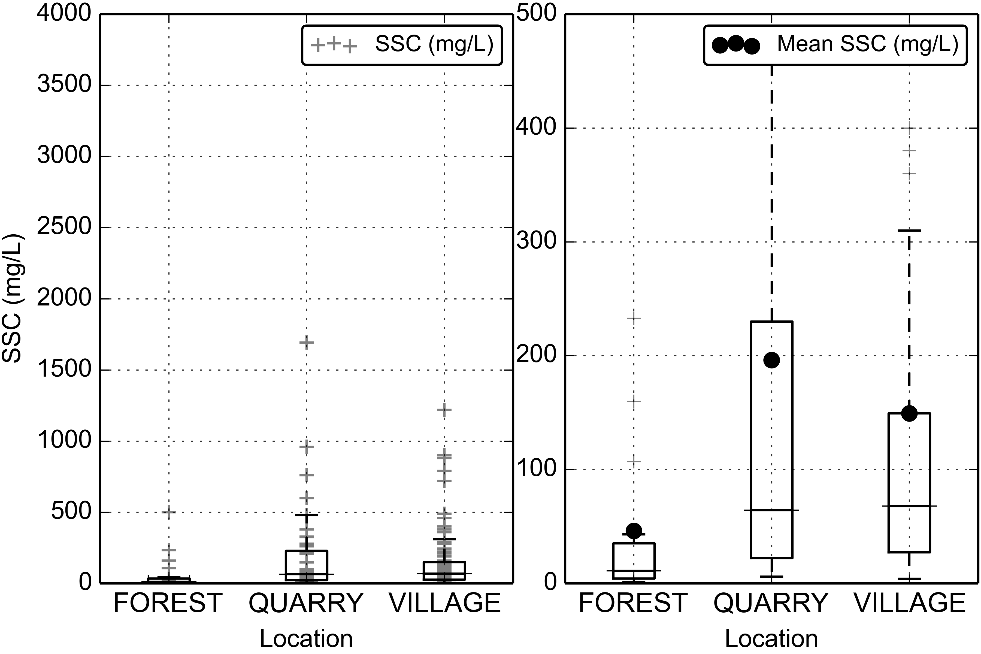

Figure 5. Boxplots of Suspended Sediment Concentration (SSC) at FOREST, QUARRY, and VILLAGE during storm periods.

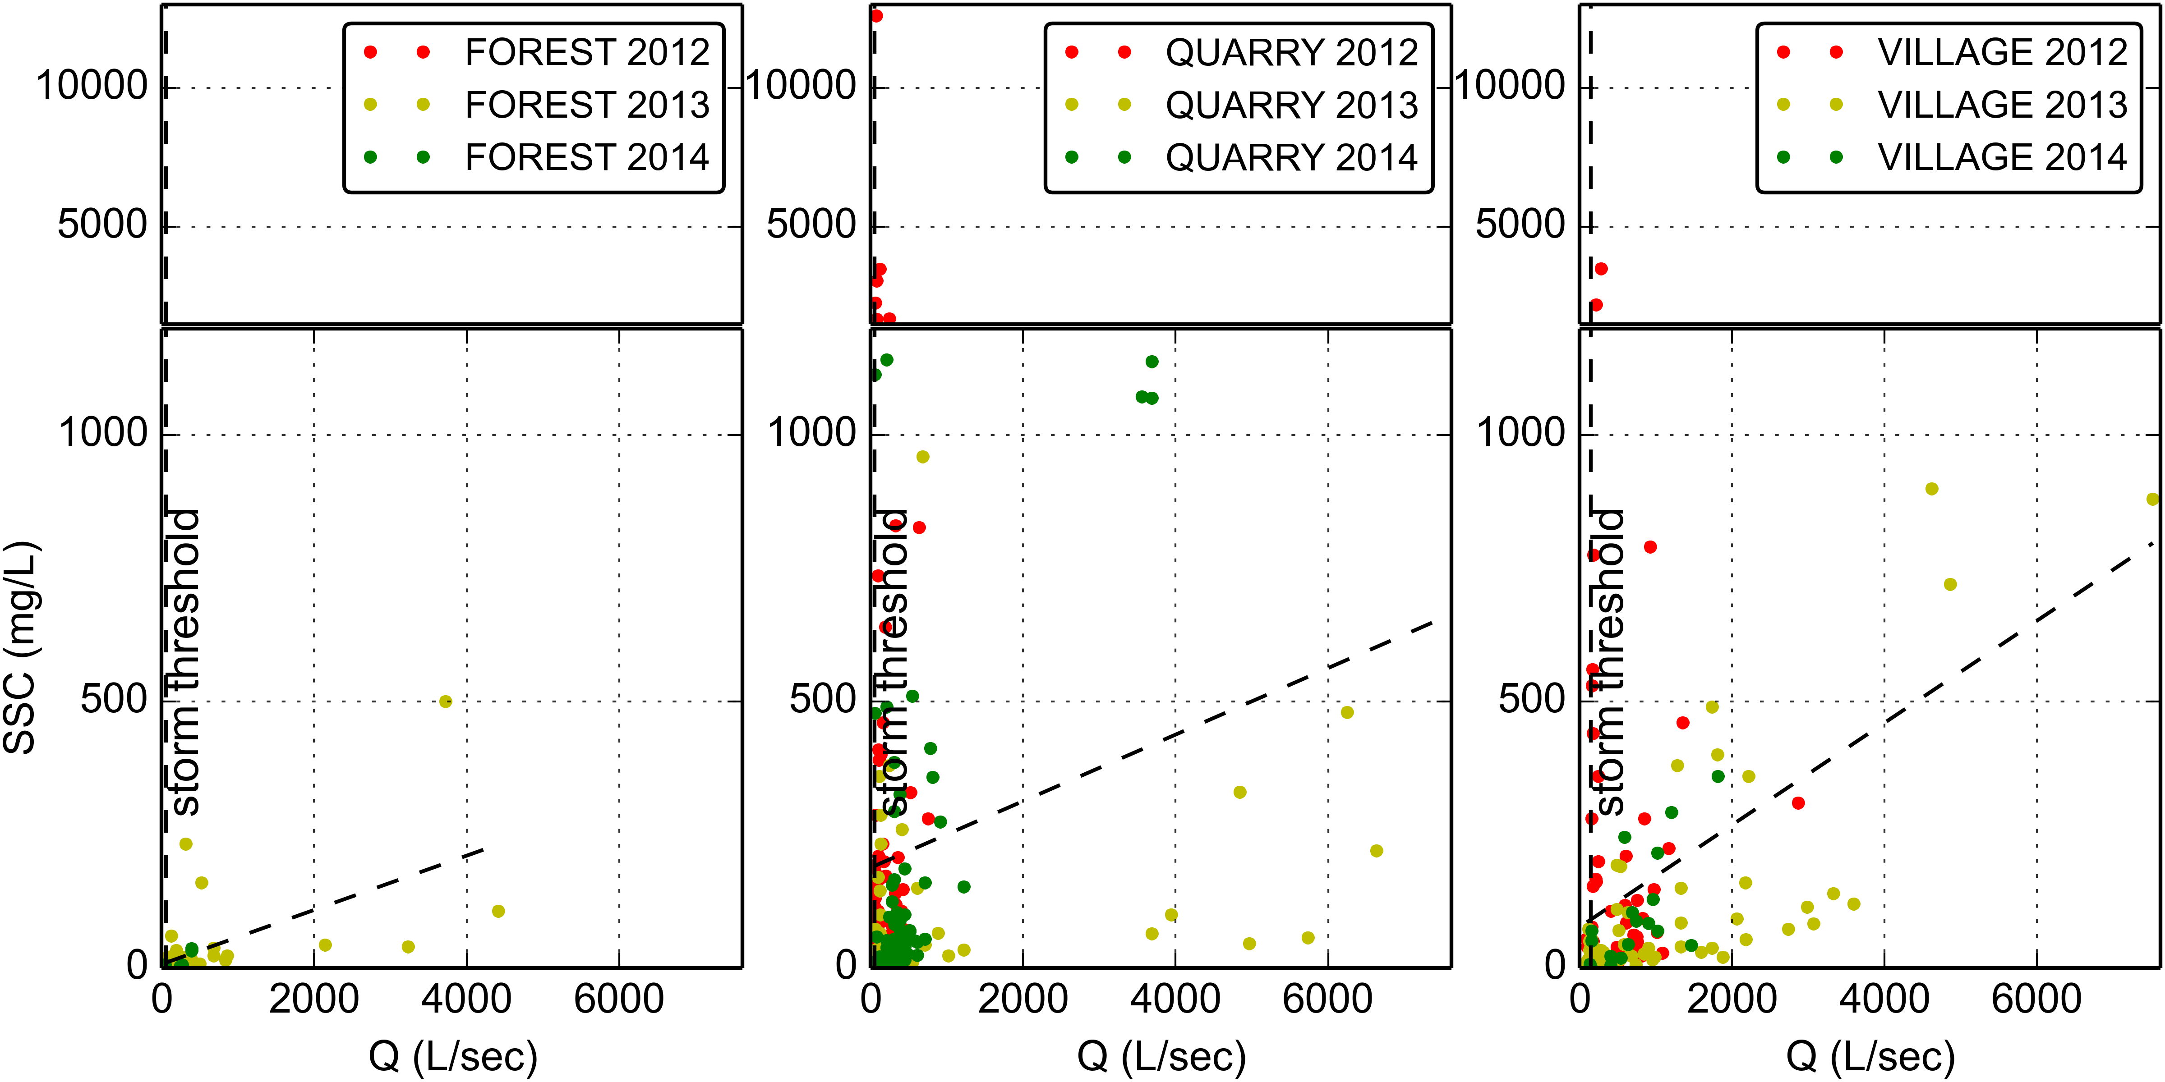

Figure 6. Water Discharge vs Suspended Sediment concentration at FOREST, QUARRY, and VILLAGE during baseflow and stormflow.

#### Turbidity

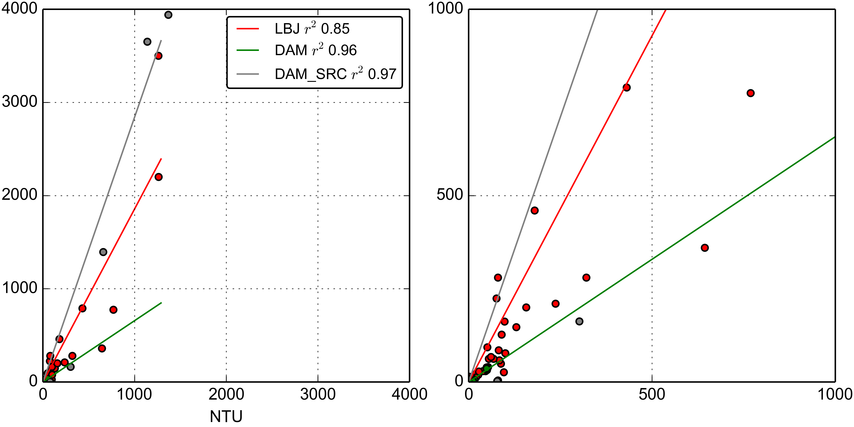

Figure 7. Turbidity-Suspended Sediment Concentration relationships for the YSI turbidimeter deployed at VILLAGE (2012-02-27 13:00:00-2012-05-23 14:00:00) and at FOREST (2013-06-13 14:30:00-2014-12-31 00:00:00).

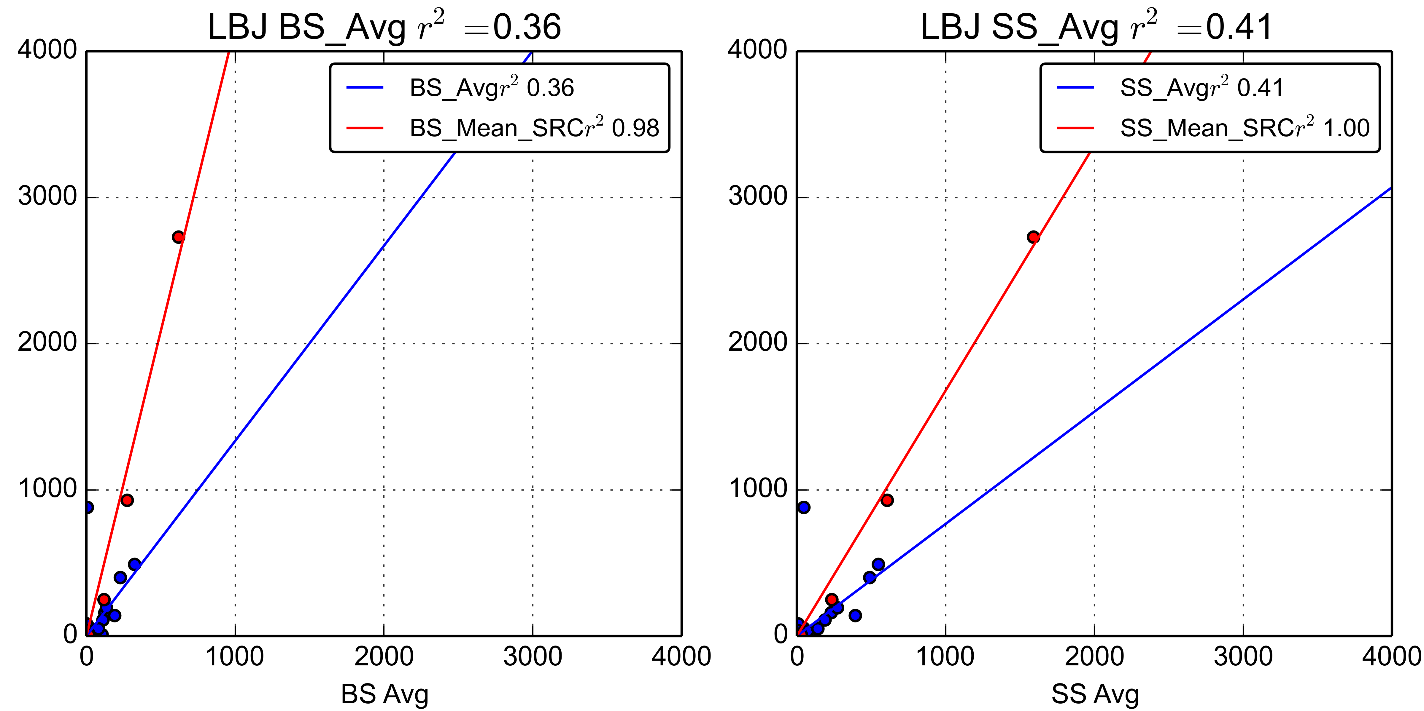

Figure 8. Turbidity-Suspended Sediment Concentration relationships for the OBS500 turbidimeter deployed at VILLAGE (2013-03-07 14:25:00-2013-07-15 14:35:00).

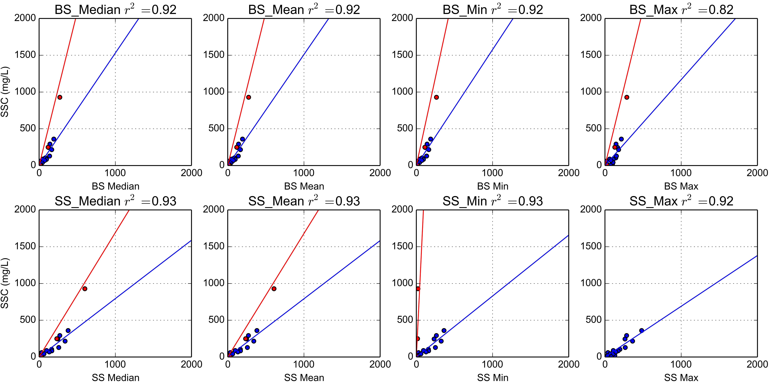

Figure 9. Turbidity-Suspended Sediment Concentration relationships for the OBS500 turbidimeter deployed at VILLAGE (2014-01-31 14:30:00-2014-03-04 09:15:00).

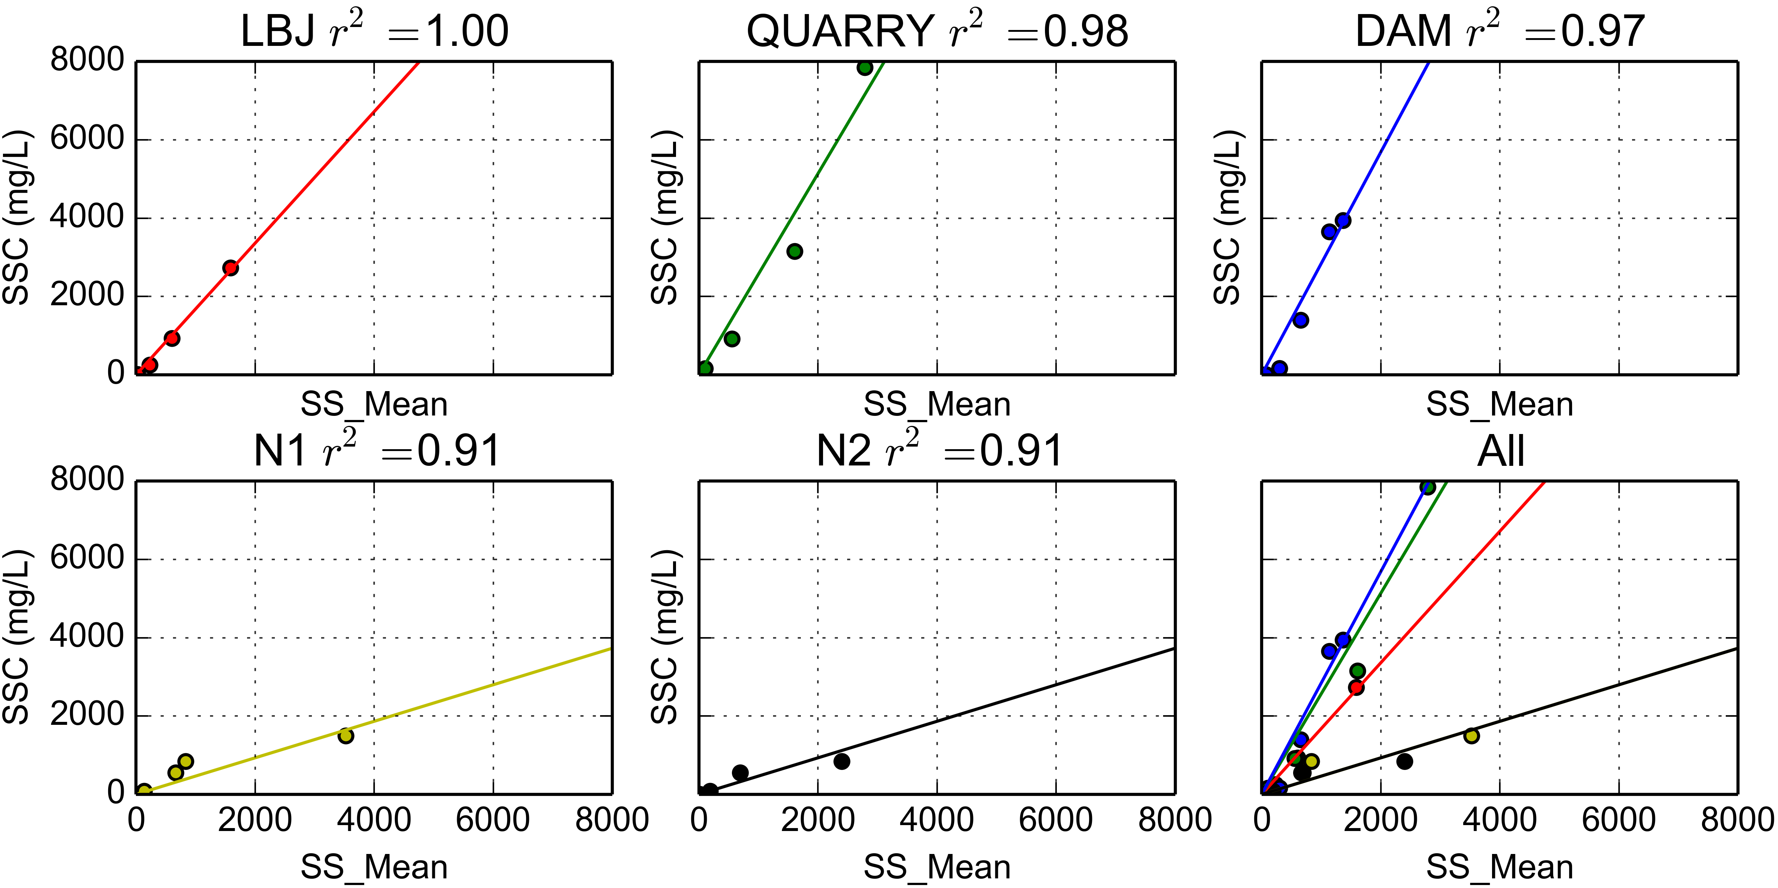

Figure 10. Synthetic Rating Curves for Turbidimeters deployed at FOREST, QUARRY, VILLAGE, Nuuuli-1 and Nuuuli-2

### Storm Events

### Comparing SSY from disturbed and undisturbed subwatersheds

Table 3 shows that lots of...

|  |  |  |  |  |  |  |  |
| --- | --- | --- | --- | --- | --- | --- | --- |
| Table 3. Sediment discharge from subwatersheds in Faga'alu | | | | | | | |
| Storm Start | Storm# | Precip (mm) | UPPER tons | LOWER tons | TOTAL tons | % Upper | % Lower |
| 2012-01-19 13:30:00 | 1 | 0 | 0.05 | 0.66 | 0.71 | 7 | 92 |
| 2012-01-25 03:45:00 | 2 | 75 | 0.32 | 0.2 | 0.52 | 61 | 38 |
| 2012-02-02 06:00:00 | 3 | 16 | 0.05 | 1.08 | 1.13 | 4 | 95 |
| 2012-02-03 01:15:00 | 4 | 24 | 0.08 | 2.38 | 2.47 | 3 | 96 |
| 2012-02-05 10:00:00 | 5 | 19 | 0.05 | 1.0 | 1.05 | 4 | 95 |
| 2012-02-05 23:00:00 | 6 | 83 | 0.44 | 8.61 | 9.05 | 4 | 95 |
| 2012-03-08 16:30:00 | 7 | 23 | 0.06 | 2.97 | 3.04 | 2 | 97 |
| 2012-03-09 06:00:00 | 8 | 18 | 0.17 | 2.64 | 2.81 | 6 | 93 |
| 2012-03-16 10:00:00 | 9 | 22 | 0.05 | 1.57 | 1.62 | 3 | 96 |
| 2012-03-17 11:45:00 | 10 | 30 | 0.07 | 3.09 | 3.16 | 2 | 97 |
| 2012-03-21 20:15:00 | 11 | 14 | 0.14 | 1.35 | 1.48 | 9 | 90 |
| 2012-03-22 05:15:00 | 12 | 0 | 0.02 | 0.12 | 0.14 | 12 | 87 |
| 2012-03-22 21:45:00 | 13 | 35 | 0.33 | 5.73 | 6.06 | 5 | 94 |
| 2012-03-25 03:30:00 | 14 | 49 | 0.64 | 10.11 | 10.75 | 5 | 94 |
| 2012-05-02 16:15:00 | 15 | 30 | 0.02 | 4.47 | 4.49 | 0 | 99 |
| 2012-05-08 04:45:00 | 16 | 25 | 0.1 | 3.71 | 3.81 | 2 | 97 |
| 2012-05-22 18:45:00 | 17 | 33 | 0.48 | 8.07 | 8.55 | 5 | 94 |
| 2012-05-23 07:45:00 | 18 | 88 | 3.86 | 3.09 | 6.95 | 55 | 44 |
| 2013-03-06 09:15:00 | 19 | 21 | 0.06 | 0.85 | 0.9 | 6 | 93 |
| 2013-04-16 11:00:00 | 20 | 53 | 0.53 | 3.88 | 4.41 | 12 | 87 |
| 2013-04-23 13:30:00 | 21 | 83 | 9.55 | 16.86 | 26.41 | 36 | 63 |
| 2013-04-30 15:00:00 | 22 | 112 | 0.48 | 7.57 | 8.05 | 5 | 94 |
| 2013-06-16 03:15:00 | 24 | 28 | 0.13 | 0.42 | 0.55 | 23 | 76 |
| 2014-02-14 14:45:00 | 25 | 18 | 0.22 | 1.54 | 1.76 | 12 | 87 |
| 2014-02-15 09:00:00 | 26 | 11 | 0.02 | 0.5 | 0.52 | 3 | 96 |
| 2014-02-18 18:15:00 | 27 | 11 | 0.0 | 0.09 | 0.09 | 1 | 98 |
| 2014-02-20 11:15:00 | 28 | 29 | 0.12 | 3.64 | 3.76 | 3 | 96 |
| 2014-02-21 11:30:00 | 29 | 51 | 1.85 | 7.71 | 9.56 | 19 | 80 |
| 2014-02-22 07:45:00 | 30 | 0 | 0.01 | 0.02 | 0.03 | 20 | 79 |
| 2014-02-24 05:30:00 | 31 | 20 | 0.06 | 0.44 | 0.5 | 12 | 87 |
| 2014-02-25 21:15:00 | 32 | 60 | 0.53 | 6.96 | 7.49 | 7 | 92 |
| 2014-02-27 02:00:00 | 33 | 35 | 0.24 | 1.94 | 2.17 | 10 | 89 |
| 2014-10-15 12:45:00 | 34 | 17 | 0.11 | 0.5 | 0.62 | 18 | 81 |
| 2014-10-15 17:45:00 | 35 | 17 | 0.19 | 0.33 | 0.52 | 36 | 63 |
| 2014-11-02 03:30:00 | 36 | 16 | 0.14 | 0.92 | 1.05 | 12 | 87 |
| 2014-11-03 17:15:00 | 37 | 43 | 1.0 | 21.75 | 22.75 | 4 | 95 |
| 2014-11-12 09:30:00 | 38 | 1 | 0.01 | 0.24 | 0.25 | 3 | 96 |
| 2014-11-12 17:15:00 | 39 | 13 | 0.3 | 0.02 | 0.32 | 94 | 5 |
| 2014-11-22 19:30:00 | 43 | 78 | 0.77 | 3.79 | 4.56 | 16 | 83 |
| 2014-11-24 21:15:00 | 44 | 20 | 0.05 | 0.52 | 0.57 | 9 | 90 |
| 2014-12-04 20:15:00 | 45 | 65 | 0.26 | 1.45 | 1.71 | 15 | 84 |
| 2014-12-09 10:15:00 | 46 | 34 | 3.1 | 12.35 | 15.45 | 20 | 79 |
| 2014-12-19 00:15:00 | 47 | 62 | 1.1 | 2.16 | 3.26 | 33 | 66 |
| 2014-12-21 00:30:00 | 48 | 143 | 2.53 | 5.08 | 7.61 | 33 | 66 |
| - | - | - | - | - | Average: | 15 | 84 |

### Disturbance Ratio

### Comparing predictors of SSY

### Fitting sediment curves

### Comparing human impact on SSY from Faga'alu watershed

## Discussion

Discussion text goes here...

## Conclusion

Conclusion text goes here...